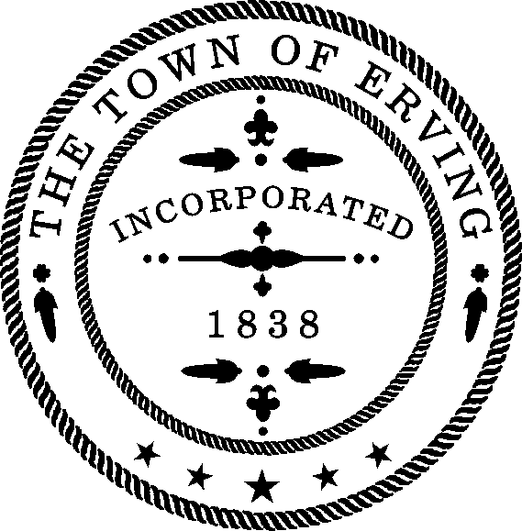
TOWN OF ERVING
Erik Eichorn, Chair
Jacquelyn Boyden
Kathleen Sadler
Renee Tela
Commissioners

Breta Petraccia
Recreation Commission Assistant

RECREATION COMMISSION

12 EAST MAIN STREET
ERVING, MASSACHUSETTS 01344

Tel. 413-422-1187
Email: recreation@erving-ma.gov

Saturday, February 24, 2024 at 1 PM
Location: Erving Public Library, 2 Care Drive, Erving MA 01344

Agenda
- Public Hearing
- Minutes (2/4/2024 & 12/3/2023) – Vote Required
- Budget:
  - FY2024
  - FY2025
- Old Business:
  - Administration
    - Strategic Plan Updates – Vote Required
  - Events – Katie/Jacquie
    - Snowtubing Review (Friday, 2/23/24)
    - Egg Hunt (Saturday, 3/30/2024
    - Summer Concert Series
  - Parks/Grounds
    - Surfacing at all playgrounds
    - Securing Pickleball nets
    - Bembury Park (formerly Church St Park)
    - Riverfront Park: Electrical work & retaining walls
    - Hammock Park
    - Vet’s Field
      - Surplus items - Vote Required
    - Zilinski Field update
  - Sports/Youth Programs
    - Basketball (Review)
    - Baseball (Instructional)
    - Summer Parks Program (Update)
- New Business
  - Street banners for Spring 2024
- Other Business
  - Bridge between School and Library
- Next meetings:
- Saturday, March 23 @ 10AM:
Topics: Budget, Capital Projects, Parks, Summer Parks Program

